Assignment 8: Deploy a project from the local machine to GitHub and vice versa.

**Create new repository**

1. Go to your Github Account. Go to your Repositories. Click New.



1. Give the repo name. Select Private and click on Create Repository.

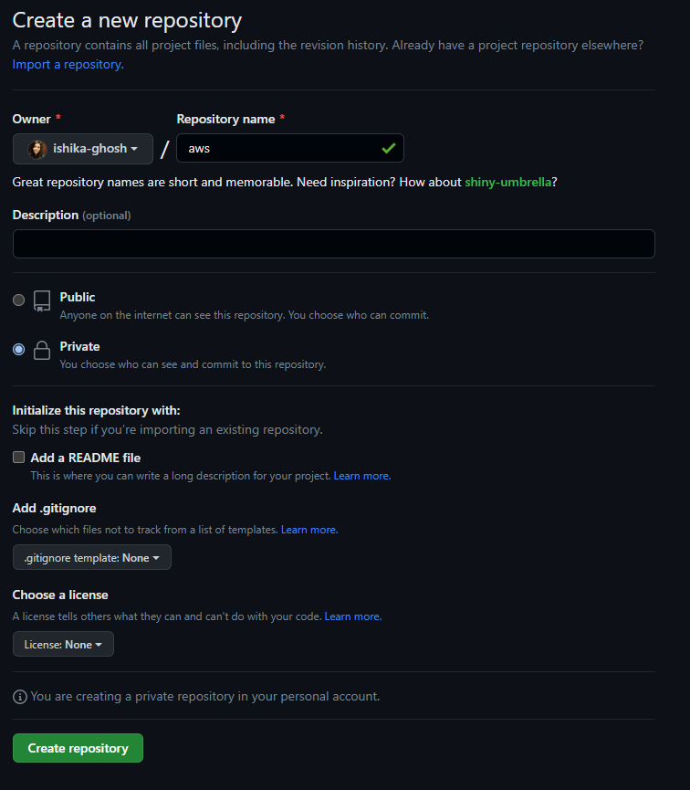

1. Click on your account at the top right, go to Settings then go to Developer settings.

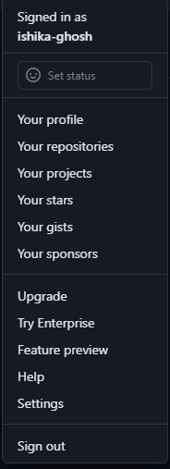

1. Select the drop-down menu of Personal access tokens and click Tokens (classic).

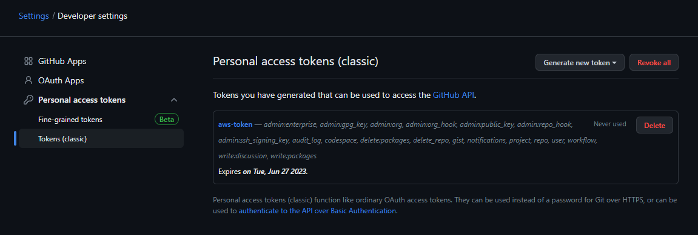

1. Click Generate new token, then generate a new token (classic).

1. Give the token name, set expiration days as 90, and select all the checkboxes. Click Generate token. Save your token.

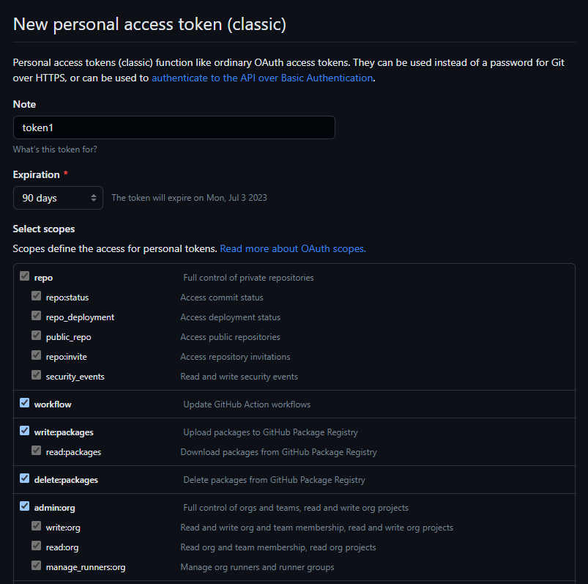

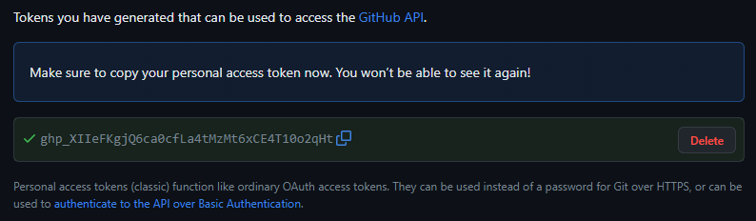

1. Go to the newly created repository and then to repository settings. Click Collaborators. Select Add People and invite people by searchingGraphical user interface

   Description automatically generated.

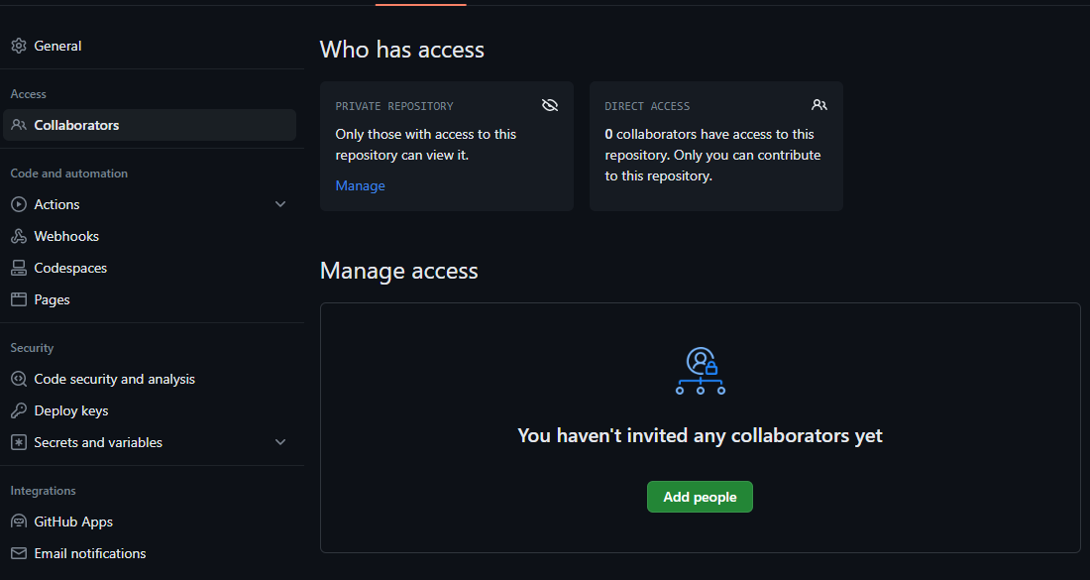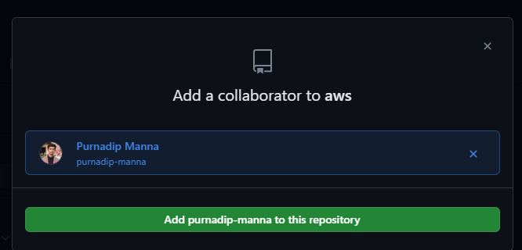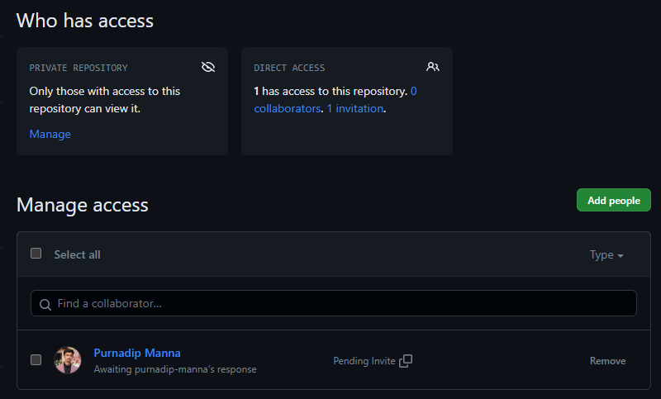

**Deploying a project from a local machine to GitHub and vice versa**

1. Open the required html folder with Git Bash.
2. Type and execute the following commands one by one.
   * + 1. git init
       2. ls -L
       3. git status
       4. git add .
       5. git status
       6. git commit -m “first commit”
       7. git remote add origin *repo link*
       8. git push-u origin master

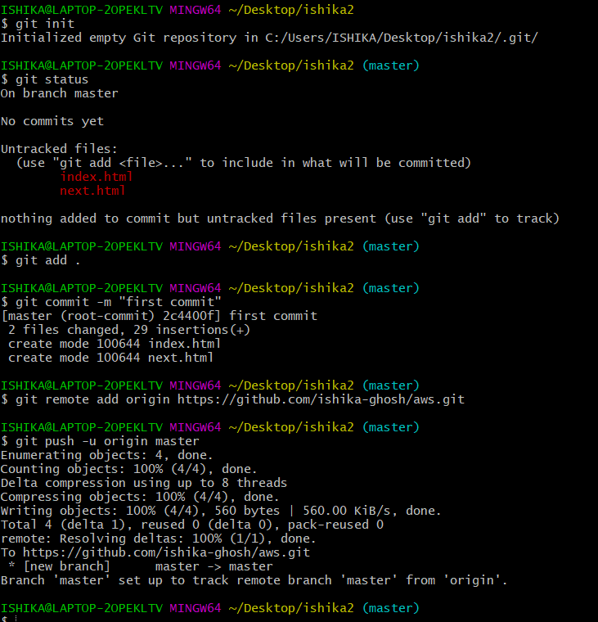

1. Sign into the GitHub account and refresh your browser you can see those files.

1. Create a new directory and open Gitbash in this folder.
2. Type and execute the following commands
   * + 1. git clone https://github.com/sudip7407/New-Repo1.git
3. Create a new repository in GitHub
4. Open Gitbash in the cloned folder (remove the already existing .git hidden folder in the folder containing the cloned project.)
5. Type and execute the following commands
   * + 1. git init
       2. git add .
       3. git commit -m “Committed”
       4. git remote add origin *repo link*
       5. git push -u origin master
6. Refresh your repository.

